­­­­­

|  |  |
| --- | --- |
|  |  |



**IMBD Project**

Process Definition

Document

Table of Contents

I. INTRODUCTION 4

1.1 Purpose 4

1.2 Objectives 4

1.3 Key Contacts 5

1.4 Minimum Pre-requisites for the Automation 5

II. AS IS Process description 5

2.1 Process Overview 5

2.2 Applications Used 7

2.3 AS IS Process Map 7

2.3.1 High Level Process Map 8

2.3.2 Detailed Level Process Map 8

2.4 Process Statistics 8

# INTRODUCTION



## Purpose

Save Time

## Objectives

* Reduce processing time per item by 80%.
* Better Monitoring of the overall activity by using the logs provided by the robots.

## Key Contacts

Add here any stakeholders that need to be informed or to approve changes to the process:

|  |  |  |  |
| --- | --- | --- | --- |
| Role | Name | Contact Details (email, phone number) | Notes |
| Business analyst | Hady Abdelaleem | [hady Abd-ElAlime | LinkedIn](https://www.linkedin.com/in/hady12345/) |  |
| RPA developer | Hady Abdelaleem | [hady Abd-ElAlime | LinkedIn](https://www.linkedin.com/in/hady12345/) |  |

# AS IS Process description



## Process Overview

|  |  |
| --- | --- |
| Item | Description/Answer |
| Process Full Name | IMBD Project Descreption Document |
| Process Area | Web Data Scraping |
| Department | Search |
| Short Description (operation, activity, outcome) | Scraping Data from IMDB |
| Role(s) required in applications to perform the process | Rap developer |
| Process schedule and frequency | All time |
| Number of times the process is ran by selected frequency | To be determine |
| Process execution time | 37.5 sec. |
| Process Restrictions | Non |
| Peak Period (s) | To be determine |
| Peak Volume Approximate increase | To be determine |
| Number of persons performing the process | One |
| Expected Volume increase during next periods | To be determine |
| Percentage Un-handled exceptions | 0% |
| Input data description | Number of Movies |
| Output Data description | Scraped Movie Data |

## AS IS Process Map

### High Level Process Map

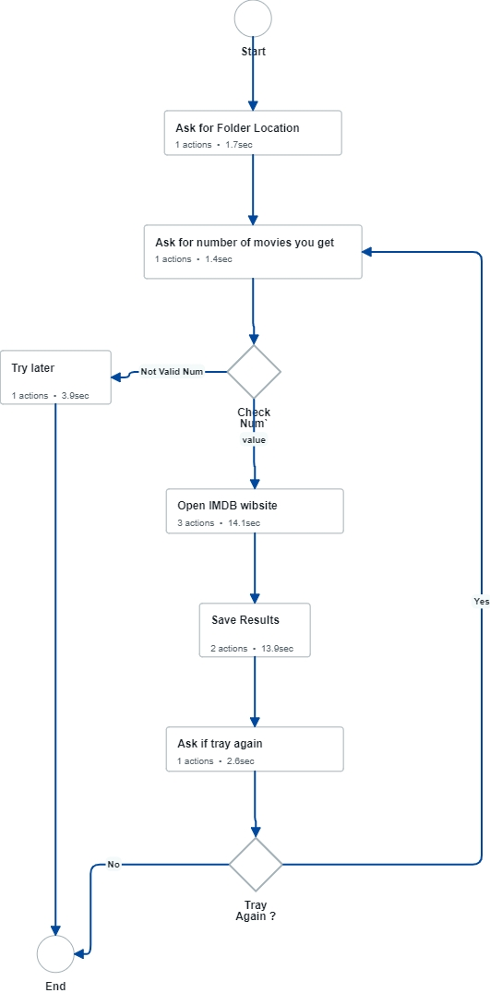

### Detailed Level Process Map

## Process Statistics

**High Level statistics**

|  |  |  |  |  |  |  |  |
| --- | --- | --- | --- | --- | --- | --- | --- |
| Processes | Windows | Actions | Mouse clicks | Keys pressed | Text entries | Hotkeys used | Time |
| 3 | 7 | 9 | 9 | 0 | 0 | 0 | 37.5 sec. |
|  |  |  |  |  |  |  |  |
|  |  |  |  |  |  |  |  |

**Detailed statistics**

|  |  |  |  |
| --- | --- | --- | --- |
| Window name | Mouse clicks | Text entries | Key pressed |
| Browse For Folder | 1 | 0 | 0 |
| How meny Movies ? | 1 | 0 | 0 |
| Message Box | 1 | 0 | 0 |
| Again ? | 1 | 0 | 0 |
| IMDb: Ratings, Reviews, and Where to Watch the Best Movies & TV Shows - School - Microsoft​ Edge | 2 | 0 | 0 |
| IMDb Top 250 Movies - School - Microsoft​ Edge | 1 | 0 | 0 |
| Untitled - Notepad | 2 | 0 | 0 |
|  |  |  |  |
|  |  |  |  |

## Detailed As Is Process Actions

|  |  |  |  |  |  |
| --- | --- | --- | --- | --- | --- |
| #Action | Input | Description | Details (Screen/Video Recording Index) | Exceptions Handling | Possible Actions |
|  |  |  |  |  |  |
|  |  |  |  |  |  |

|  |  |
| --- | --- |
| 1. Ask for Folder Location | |
|  | **Est. time: 1.7 sec.** |

|  |  |
| --- | --- |
|  |  |
|  | Est. time: 1.7 sec. |
| image | Allow user to Enter the output file location. |

|  |  |
| --- | --- |
| 1. Ask for the number of movies you get | |
|  | **Est. time: 1.4 sec.** |

|  |  |
| --- | --- |
|  |  |
|  | Est. time: 1.4 sec. |
| image | Check the number five times, must be 1-250 |

|  |  |
| --- | --- |
| 1. Check Num` | |
| If 'Valid' then go to '4. Open IMDB wibsite '  If 'Not Valid Num' then go to '9. Try later ' | **Est. time: 0.0 sec.** |

|  |  |
| --- | --- |
| 1. Open IMDB wibsite | |
|  | **Est. time: 14.1 sec.** |

|  |  |
| --- | --- |
|  |  |
|  | Est. time: 2.3 sec. |
| image | **Open IMDB web site**  **https://www.imdb.com/** |

|  |  |
| --- | --- |
|  |  |
|  | Est. time: 2.8 sec. |
| image | Click Top 250 Movies |

|  |  |
| --- | --- |
|  |  |
|  | Est. time: 9.1 sec. |
| image | Get the data of movies |

|  |  |
| --- | --- |
| 1. Save Results | |
|  | **Est. time: 13.9 sec.** |

|  |  |
| --- | --- |
|  |  |
|  | Est. time: 12.4 sec. |
| image | Open Notepad |

|  |  |
| --- | --- |
|  |  |
|  | Est. time: 1.5 sec. |
| image | Save Text file in folder location |

|  |  |
| --- | --- |
| 1. Ask if tray again | |
|  | **Est. time: 2.6 sec.** |

|  |  |
| --- | --- |
|  |  |
|  | Est. time: 2.6 sec. |
| image | Ask user if he need to try again |

|  |  |
| --- | --- |
| 1. Tray Again ? | |
| If 'Yes' then go to '2. Ask for number of movies you get'  If 'No' then go to '8. End' | **Est. time: 0.0 sec.** |

|  |  |
| --- | --- |
| * 1. Go to: Ask for number of movies you get |  |
|  | Est. time: 0.0 sec. |
|  | Action: NONE |

|  |  |
| --- | --- |
| 1. Try later | |
|  | **Est. time: 3.9 sec.** |

|  |  |
| --- | --- |
|  |  |
|  | Est. time: 3.9 sec. |
| image | Action: Click |

|  |  |
| --- | --- |
| 1. End | |
|  | **Est. time: 0.0 sec.** |

